**Project 3 - Displacement Mapping, Bump Mapping, and Lighting**

Explanation:

Using the provided formulas (and some quick googling about maths within C++) I believe that I have managed to find the normals and apply them in a satisfactory manner. I combined the declaration of the vec3’s with the normalize call, so that was a small shortcut that I had used. The formulas for distortion worked as they were taking an existing object, and modifying it in relation to a formula. Locating normals works (or so I believe it does) through following the given derivatives to calculate normal values we need for our mapping.

Screenshot comparisons:

**uA**

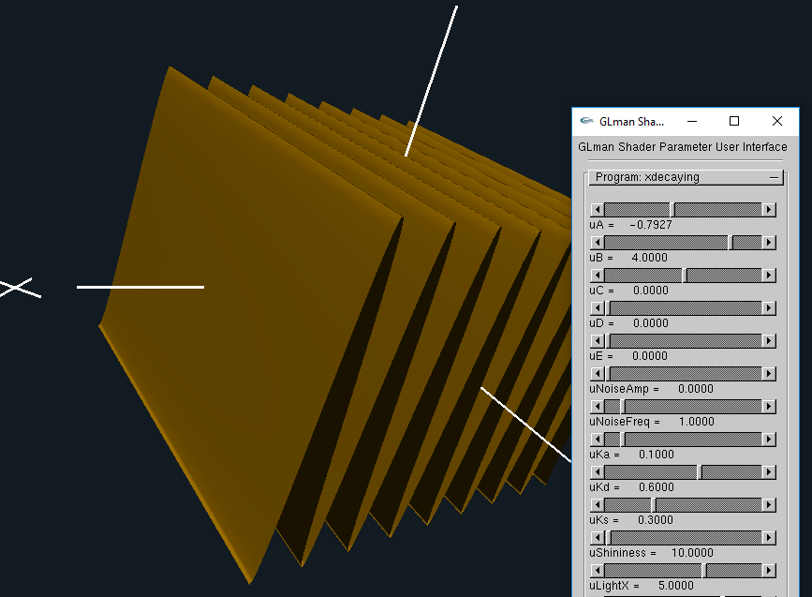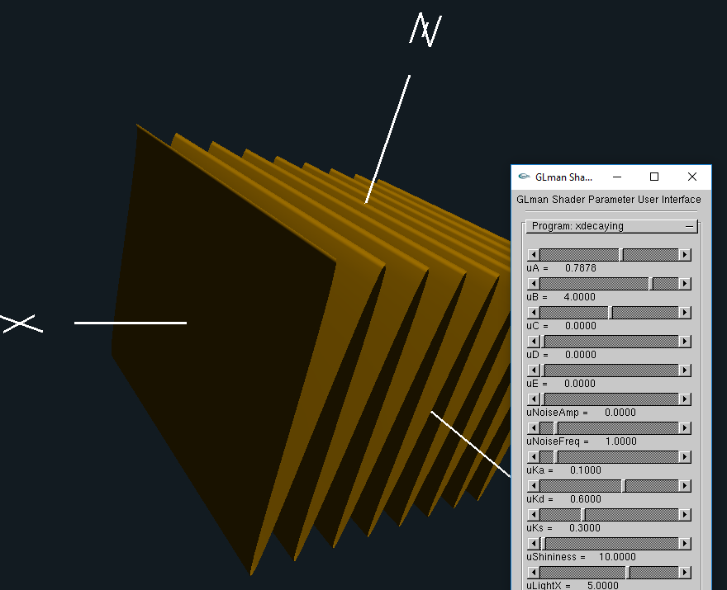

**uB**

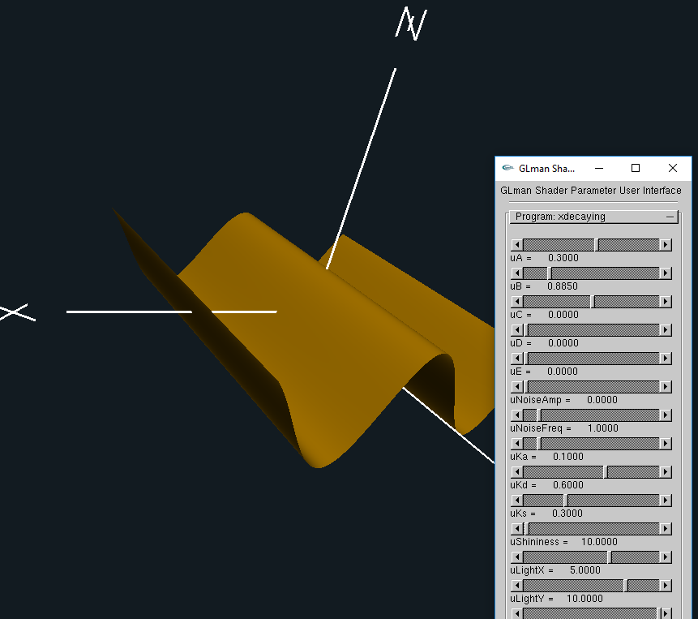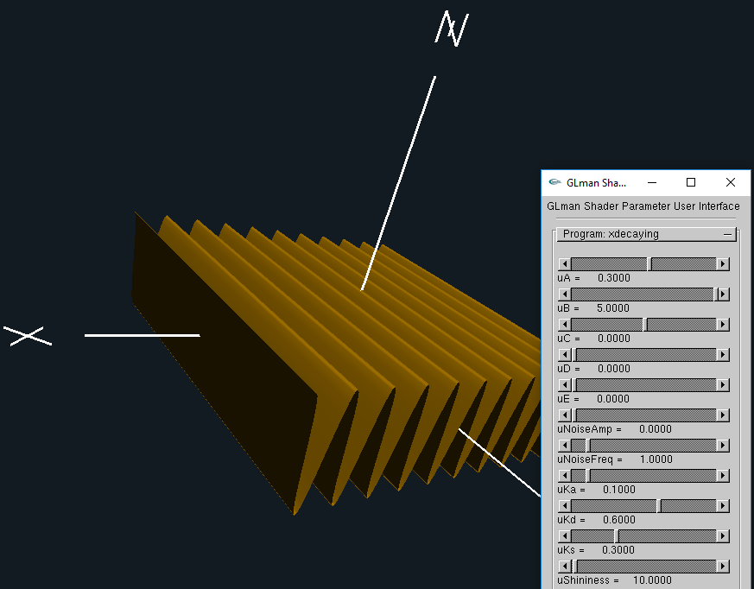

**uC**

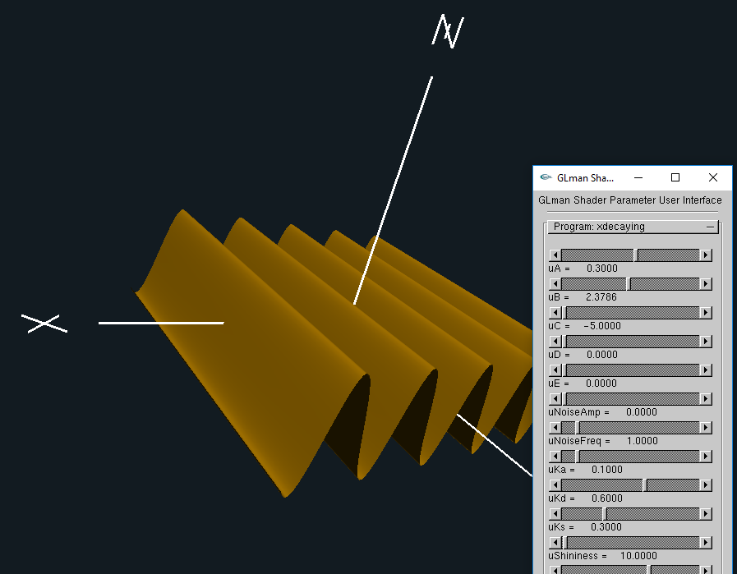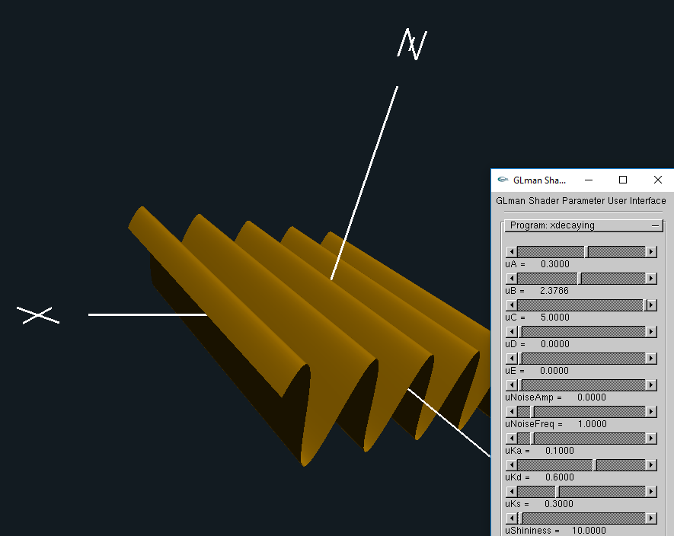

**uD**

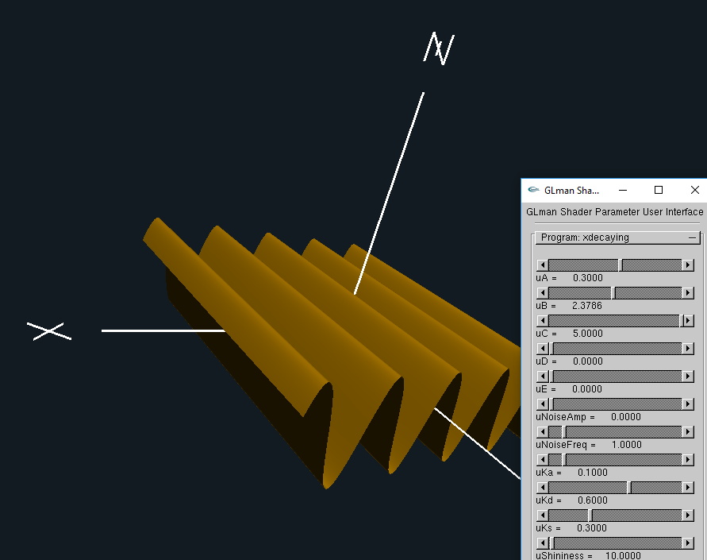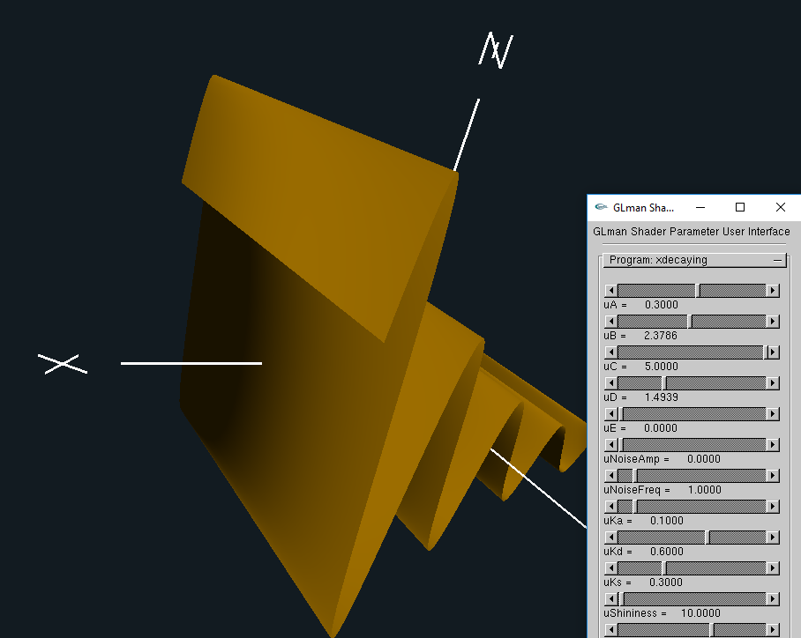

**uE**

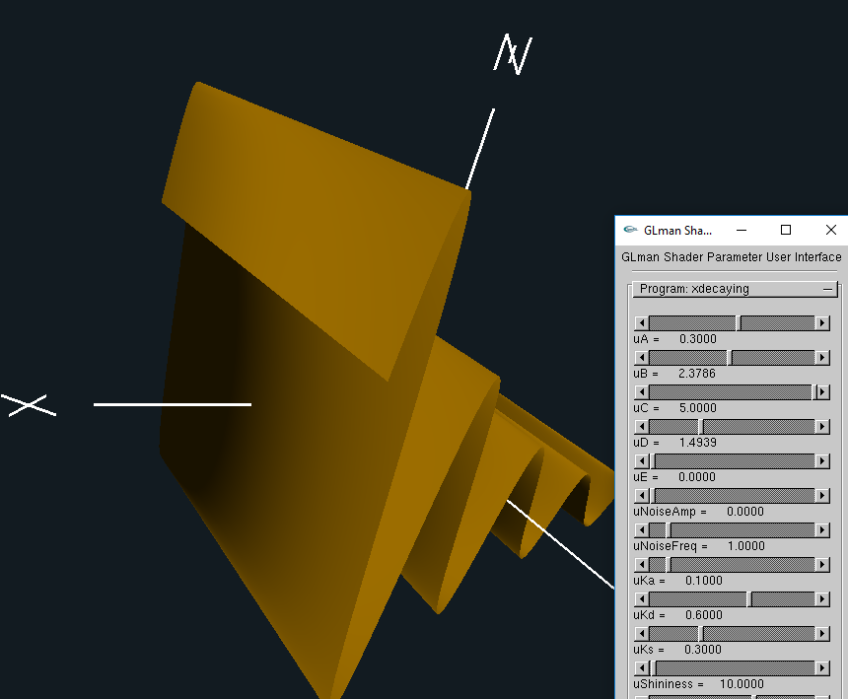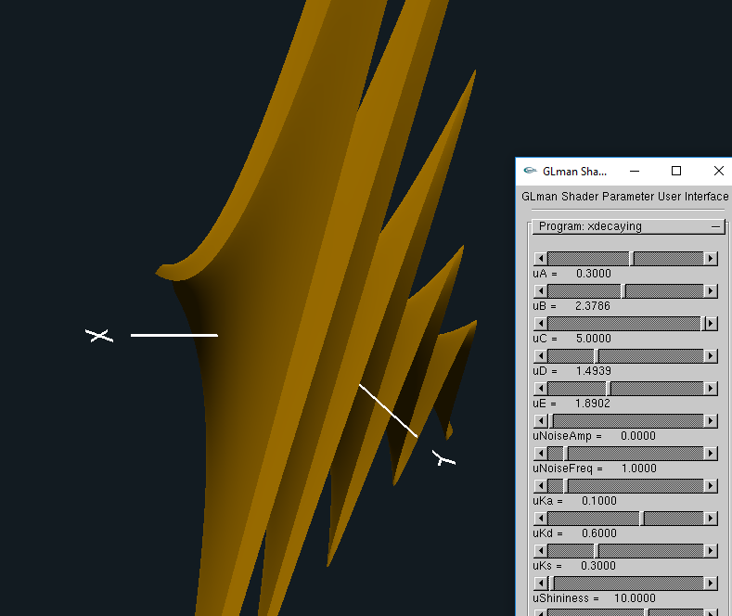

**Normals**

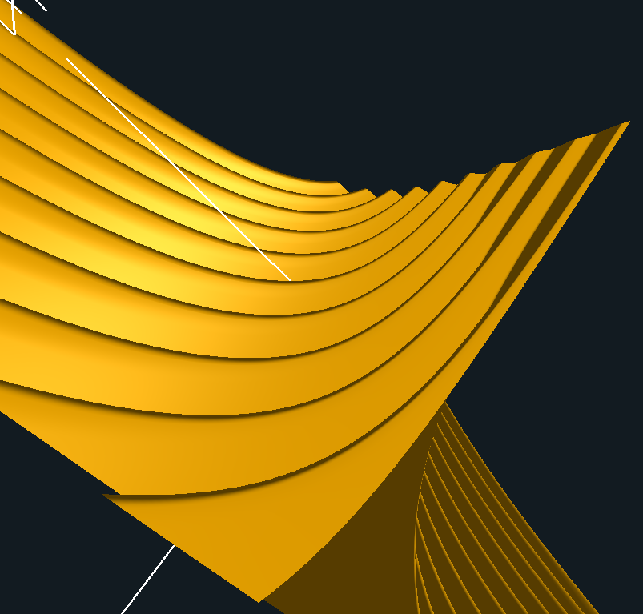

**Bump**

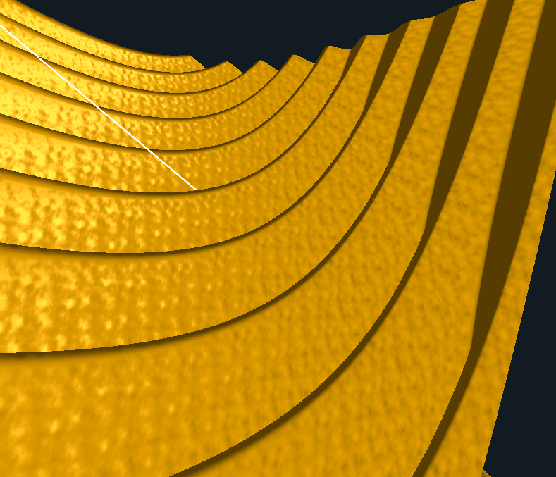

Video Link:<https://media.oregonstate.edu/media/t/0_erc1b531>

Thanks, and have a great day!